**Add CSS to our JSP page**

**Add CSS in JSP page**:

For add CSS in our JSP page we have to do the following thing

1. Configure Spring to serve up our resource’s directory
2. Create “**resources**” directory and “**css**” sub-directory.
3. Add the following “**css**” file inside “**resources/css**”
   1. [add-customer-style.css](https://github.com/ruhulmath08/Spring_Hibernate_ChadBarby/blob/master/28-33.%20Build%20a%20Database%20Web%20App%20-%20SpringMVC%20and%20Hibernate/28-33-SpringMVC-Hibernate-CRUD/WebContent/resources/css/add-customer-style.css)
   2. [style.css](https://github.com/ruhulmath08/Spring_Hibernate_ChadBarby/blob/master/28-33.%20Build%20a%20Database%20Web%20App%20-%20SpringMVC%20and%20Hibernate/28-33-SpringMVC-Hibernate-CRUD/WebContent/resources/css/style.css)
4. References css file into JSP page

**1) Configure Spring to serve up our resource’s directory**:

In our “**spring-mvc-crud-demo-servlet.xml**” file add the following code

<!-- Add support for reading web resources: css, images, js, etc ... -->

<mvc:resources mapping=*"/resources/**"* location=*"/resources/"*> </mvc:resources>

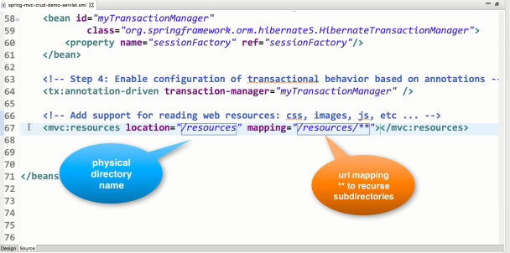

**2) Create “resources” directory and “css” sub-directory**:

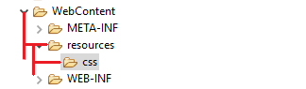

**3) Add the following css file inside “resources/css”**:

**File: add-customer-style.css**:

|  |
| --- |
| form { |
|  | margin-top: 10px; |
|  | } |
|  |  |
|  | label { |
|  | font-size: 16px; |
|  | width: 100px; |
|  | display: block; |
|  | text-align: right; |
|  | margin-right: 10px; |
|  | margin-top: 8px; |
|  | margin-bottom: 8px; |
|  | } |
|  |  |
|  | input { |
|  | width: 250px; |
|  | border: 1px solid #666; |
|  | border-radius: 5px; |
|  | padding: 4px; |
|  | font-size: 16px; |
|  | } |
|  |  |
|  | .save { |
|  | font-weight: bold; |
|  | width: 130px; |
|  | padding: 5px 10px; |
|  | margin-top: 30px; |
|  | background: #cccccc; |
|  | } |
|  |  |
|  | table { |
|  | border-style:none; |
|  | width:50%; |
|  | } |
|  |  |
|  | tr:nth-child(even) {background: #FFFFFF} |
|  | tr:nth-child(odd) {background: #FFFFFF} |
|  |  |
|  | tr { |
|  | border-style:none; |
|  | text-align:left; |
|  | } |

**File: style.css**:

|  |
| --- |
| html, body{ |
|  | margin-left:15px; margin-right:15px; |
|  | padding:0px; |
|  | font-family:Verdana, Arial, Helvetica, sans-serif; |
|  | } |
|  |  |
|  | table { |
|  | border-collapse:collapse; |
|  | border-bottom:1px solid gray; |
|  | font-family: Tahoma,Verdana,Segoe,sans-serif; |
|  | width:71%; |
|  | } |
|  |  |
|  | th { |
|  | border-bottom:1px solid gray; |
|  | background:none repeat scroll 0 0 #09c332; |
|  | padding:10px; |
|  | color: #FFFFFF; |
|  | } |
|  |  |
|  | tr { |
|  | border-top:1px solid gray; |
|  | text-align:center; |
|  | } |
|  |  |
|  | tr:nth-child(even) {background: #FFFFFF} |
|  | tr:nth-child(odd) {background: #BBBBBB} |
|  |  |
|  | #wrapper {width: 100%; margin-top: 0px; } |
|  | #header {width: 70%; background: #09c332; margin-top: 0px; padding:15px 0px 15px 15px;} |
|  | #header h2 {width: 100%; margin:auto; color: #FFFFFF;} |
|  | #container {width: 100%; margin:auto} |
|  | #container h3 {color: #000;} |
|  | #container #content {margin-top: 20px;} |
|  |  |
|  | .add-button { |
|  | border: 1px solid #666; |
|  | border-radius: 5px; |
|  | padding: 4px; |
|  | font-size: 12px; |
|  | font-weight: bold; |
|  | width: 120px; |
|  | padding: 5px 10px; |
|  |  |
|  | margin-bottom: 15px; |
|  | background: #cccccc; |
|  | } |

**4) References css file into JSP page**:

<head>

<title>Customer List</title>

<!-- reference our style sheet -->

<link type=*"text/css"*

rel=*"stylesheet"*

href=*"*${pageContext.request.contextPath}*/resources/css/style.css"*/>

</head>

Now if we run our program, we will see the following output.

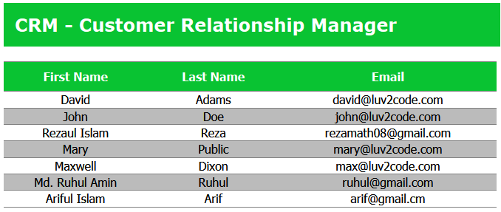

Add CSS to our JSP page